COMSATS UNIVERSITY ISLAMABAD
Department of Computer Science & Engineering
CYC386 — SECURE SOFTWARE DESIGN & DEVELOPMENT
SECURITY TESTING REPORT
SecureVault Bank — Secure Banking Platform
Prepared by: Zainab — Security Analyst (Member 2)
Instructor: Engr. Muhammad Ahmad Nawaz
Course: CYC386 — Secure Software Design & Development

1. EXECUTIVE SUMMARY
This report documents the complete security testing activities performed on the SecureVault Bank platform as part of CYC386 — Secure Software Design & Development. Testing was conducted by Zainab (Security Analyst — Member 2) and covers Static Application Security Testing (SAST), Dynamic Application Security Testing (DAST), manual API Penetration Testing, and AI/ML-powered anomaly detection across three microservices: auth-service (port 8001), user-service (port 8002), and transaction-service (port 8003).

Activity | Tool Used | Status | Key Finding
SAST — Python Code | Bandit | Complete | 0 issues in application code
SAST — Full Codebase | SonarCloud | Complete | 2 bugs, 6 security hotspots in memory_safe.c
CI/CD Security Pipeline | CodeQL (GitHub Actions) | Complete | Pipeline passing — Python code clean
DAST — Auth Service | OWASP ZAP | Complete | 6 alerts — missing security headers
API Pentesting | Postman | Complete | RBAC working; rate limiting gap identified
AI/ML Anomaly Detection | scikit-learn Isolation Forest | Complete | 3/3 attack scenarios detected successfully

2. SAST RESULTS — BANDIT

2.1 Tool Overview
Bandit is a Python-specific SAST tool that analyzes source code for common security issues. It was run against the actual application code files in the SecureVault repository, excluding virtual environment folders.

2.2 Scan Configuration
- Tool: Bandit v1.9.4
- Target: src/auth_service/main.py, src/auth_service/security.py, src/transaction_service/main.py, src/user_service/main.py, src/auth_service/models.py, src/user_service/models.py, src/transaction_service/models.py, src/auth_service/database.py
- Total lines of code scanned: 261
- Command: python -m bandit -r src/ [specific files] -f txt -o bandit-clean-report.txt

2.3 Results
Severity | Count | Interpretation
High | 0 | No high-severity issues found
Medium | 0 | No medium-severity issues found
Low | 0 | No low-severity issues found
Total | 0 | Application code is CLEAN
Conclusion: The Python application code (auth_service, user_service, transaction_service) passed Bandit analysis with zero security issues. This confirms secure coding practices were followed in the microservices implementation including proper use of bcrypt for password hashing, JWT RS256 for authentication, and parameterised database queries.
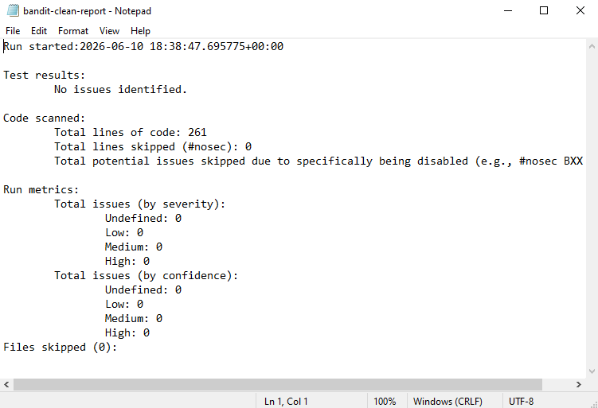

3. SAST RESULTS — SONARCLOUD

3.1 Tool Overview
SonarCloud is a cloud-based SAST platform providing continuous code quality and security analysis. The SecureVault forked repository (github.com/Zainab-Shakil/securevault-platform) was connected and automatic analysis was enabled.

3.2 Summary Dashboard
Metric | Grade | Count | Status
Security | A | 0 open issues | PASS
Reliability | E | 2 bugs | FAIL — in memory_safe.c only
Maintainability | A | 27 issues | PASS
Duplications | — | 9.5% | Acceptable

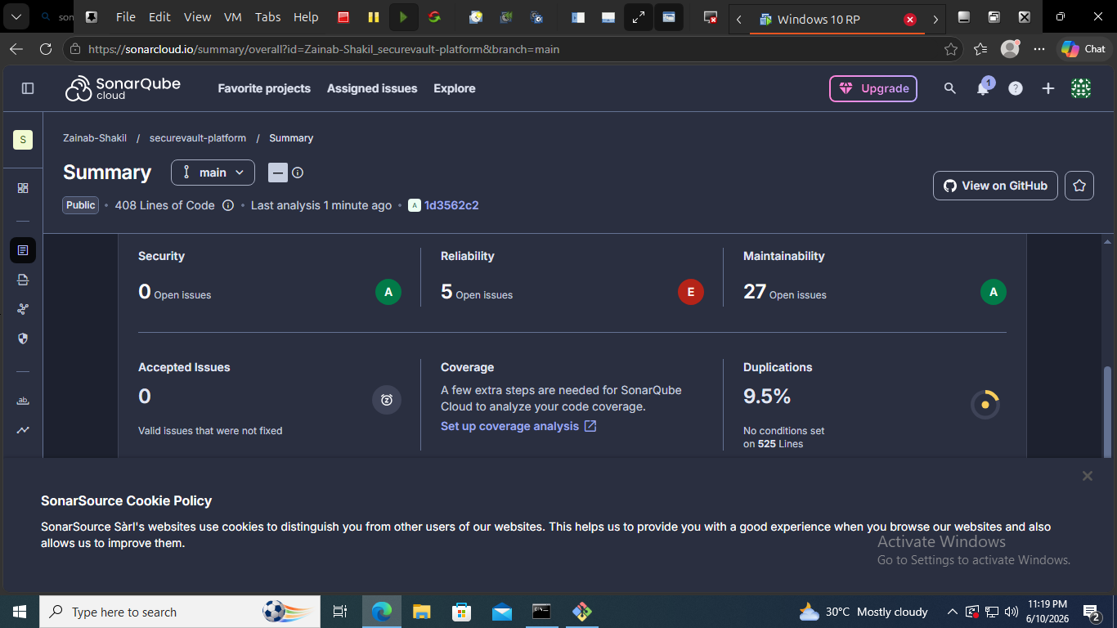

3.3 Reliability Issues — memory_safe.c
All reliability issues (grade E) are concentrated in src/memory_safe.c — a deliberately vulnerable C file created to demonstrate classic memory safety vulnerabilities. The Python microservice files all received grade A.
Line | Vulnerability Type | CWE | Description | Severity
13 | Buffer Overflow | CWE-121 | strcpy() used with no bounds checking — no size limit on destination buffer | HIGH
31 | Format String Vulnerability | CWE-134 | printf(input) — user-controlled format string passed directly to printf | HIGH
50 | Use After Free | CWE-416 | Memory accessed via printf after free() call — undefined behaviour | HIGH

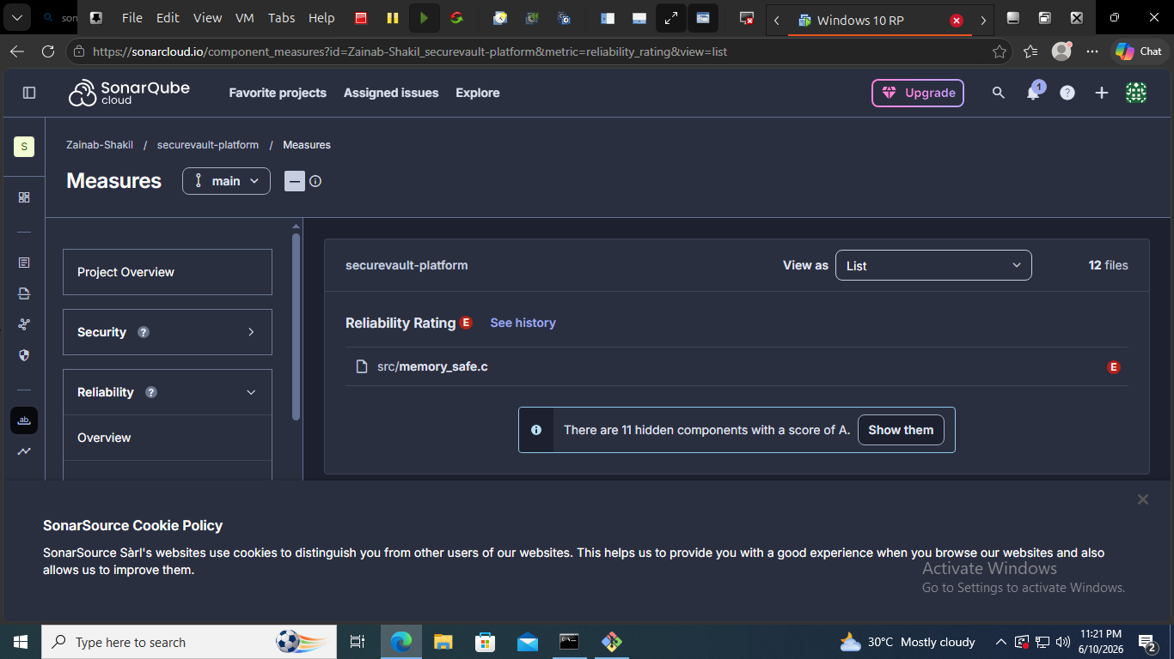

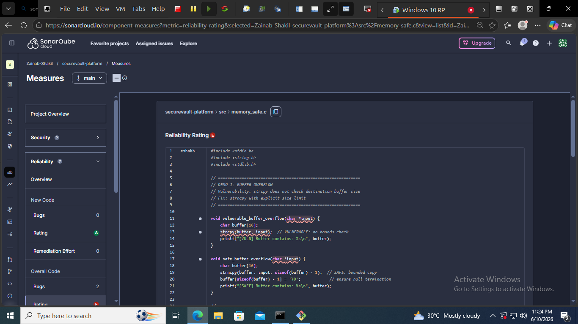

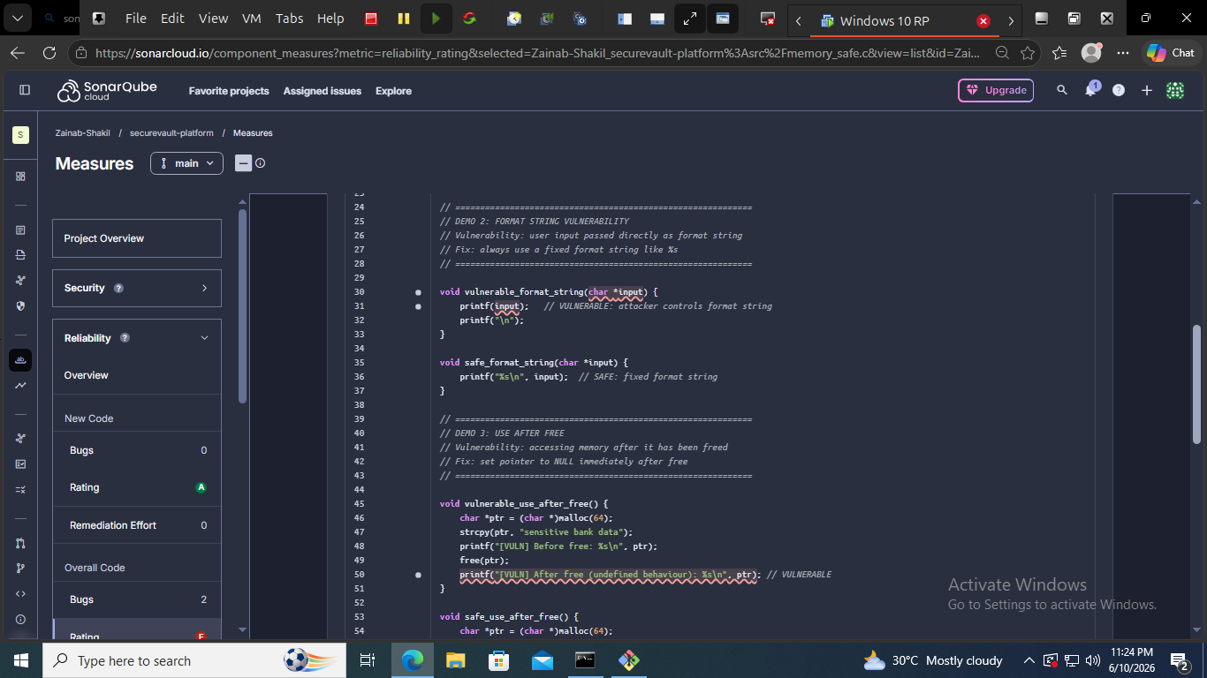

3.4 Security Hotspots
File | Hotspots | Status
src/memory_safe.c | 4 | Deliberately vulnerable demo file
src/memory_safe_only.c | 2 | Deliberately vulnerable demo file
All Python service files | 0 | Clean — no hotspots

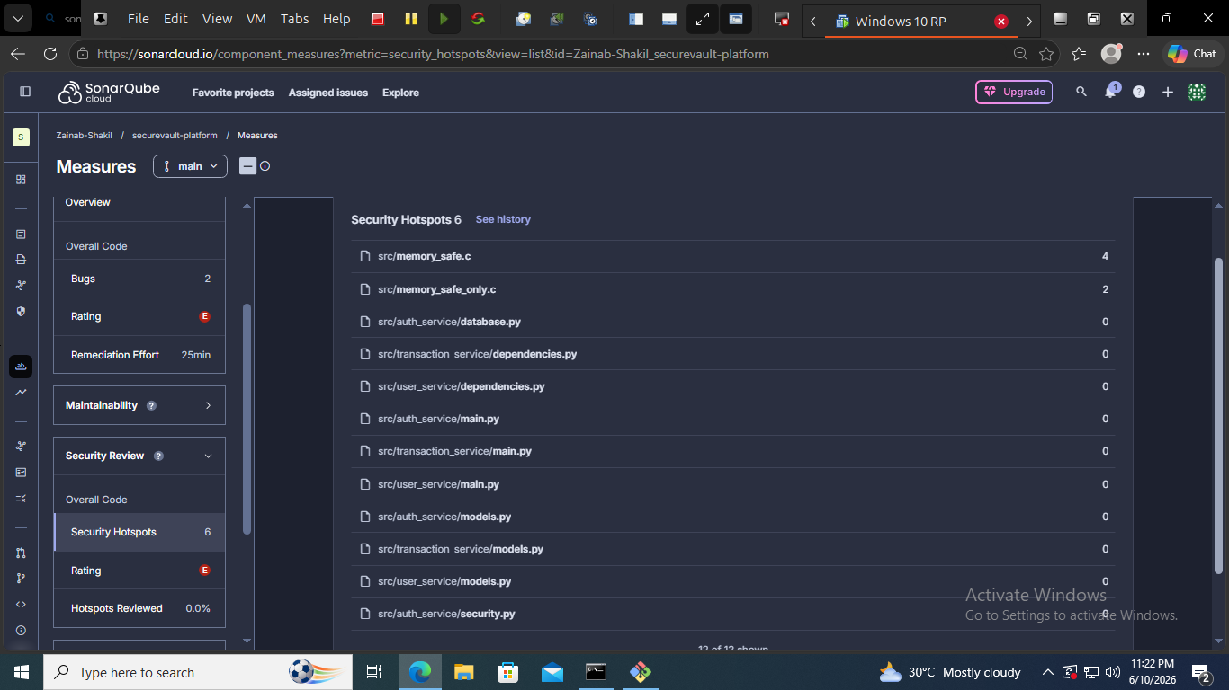

4. CI/CD SECURITY PIPELINE — CODEQL

4.1 Pipeline Configuration
A GitHub Actions workflow (.github/workflows/sast.yml) was created and committed to the forked repository to automate security scanning on every push and pull request.

4.2 Workflow Details
- Tool: GitHub CodeQL v3
- Trigger: push and pull_request events
- Language: Python
- Query suite: security-and-quality
- Status: PASSING (green checkmark)
- Run time: 1 minute 4 seconds
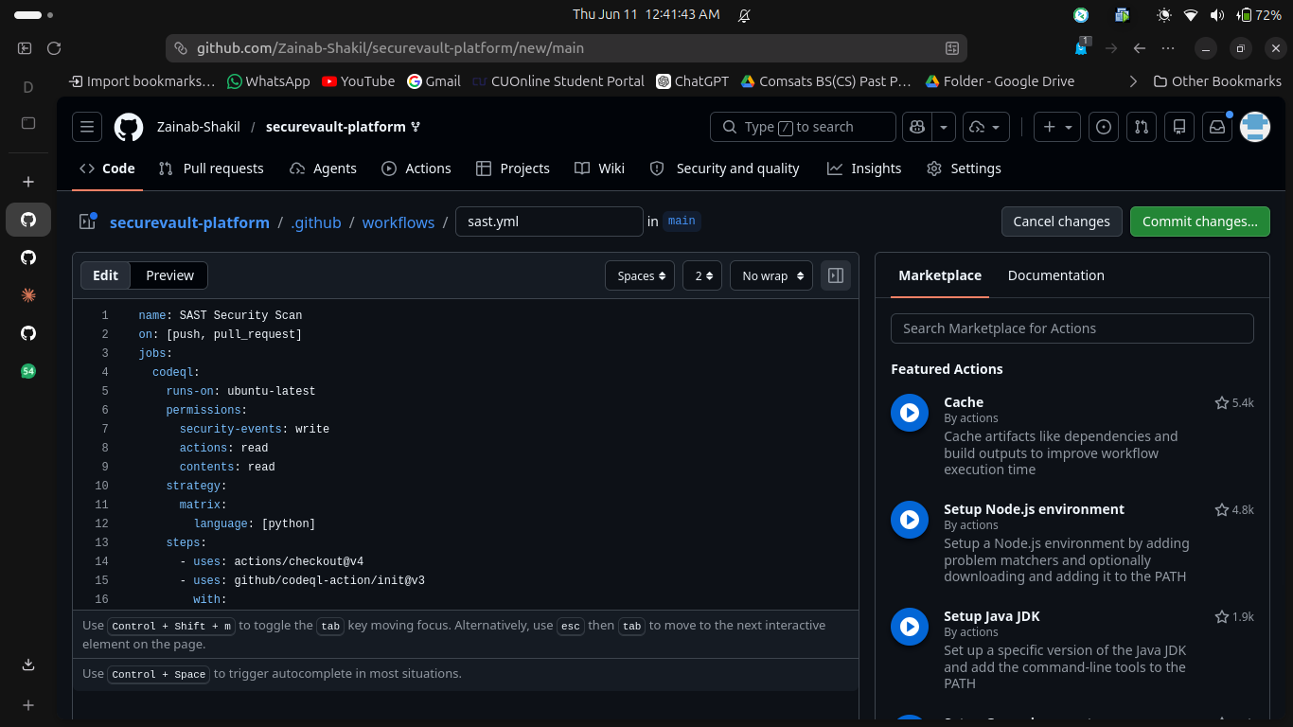

4.3 Result
CodeQL analysis completed successfully with no critical findings in the Python codebase. The pipeline is configured as a quality gate — any future commits introducing security vulnerabilities will be flagged automatically before merging.
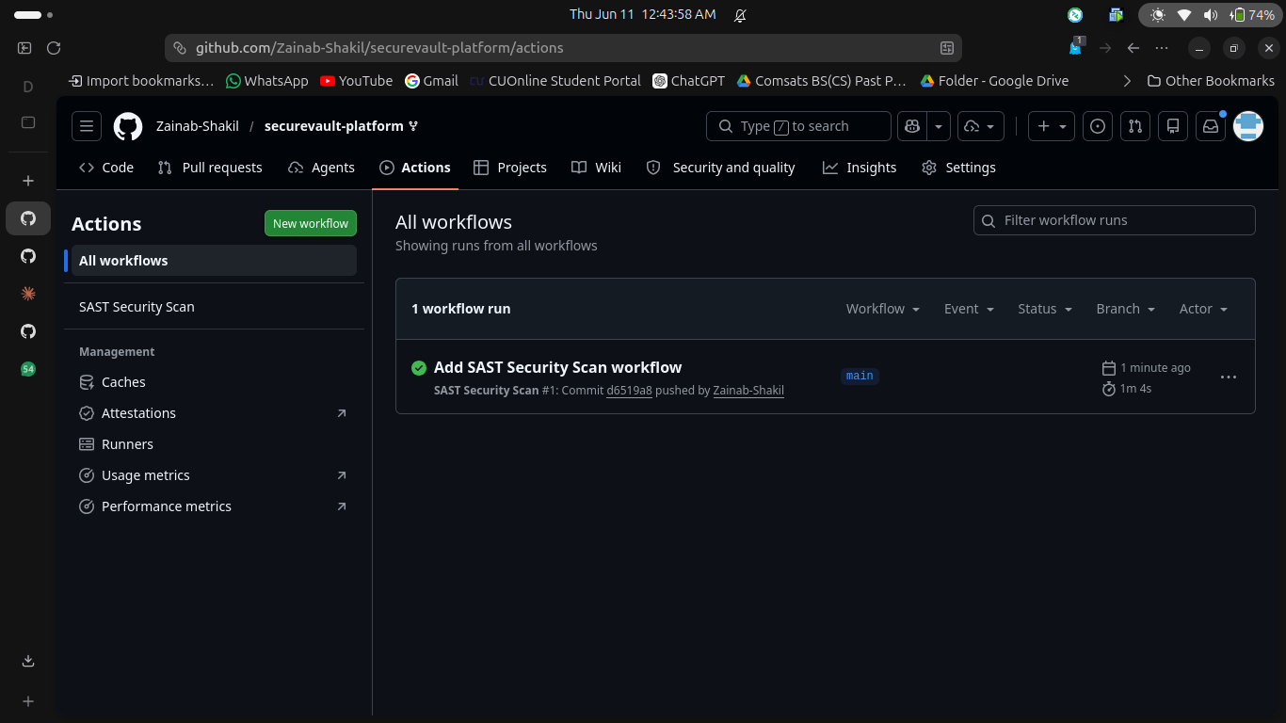

5. API PENETRATION TESTING — POSTMAN

5.1 Test Environment
- Tool: Postman (web)
- Target: SecureVault microservices running on 172.16.171.165
- Auth Service: http://172.16.171.165:8001
- User Service: http://172.16.171.165:8002
- Transaction Service: http://172.16.171.165:8003

5.2 Test Cases & Results
Test ID | Test Case | Endpoint | Payload | Expected | Actual | Result
PT-01 | User Registration | POST /auth/register | Valid JSON credentials | 201 Created | 201 Created — role: customer | PASS
PT-02 | Valid Login — JWT | POST /auth/login | Correct credentials | 200 OK + JWT token | 200 OK — access_token returned | PASS
PT-03 | Expired JWT | GET /users/me | Expired Bearer token | 401 Unauthorized | 401 — Invalid or expired token | PASS
PT-04 | IDOR — Admin Endpoint | GET /users/3 | Customer JWT token | 403 Forbidden | 403 — Admin access required | PASS
PT-05 | Brute Force Login | POST /auth/login | Wrong password x19 | 429 Too Many Requests | 401 Unauthorized (no rate limit) | VULNERABILITY
PT-06 | SQL Injection | POST /auth/login | admin' OR '1'='1 | 401 Unauthorized | 401 — Invalid username or password | PASS

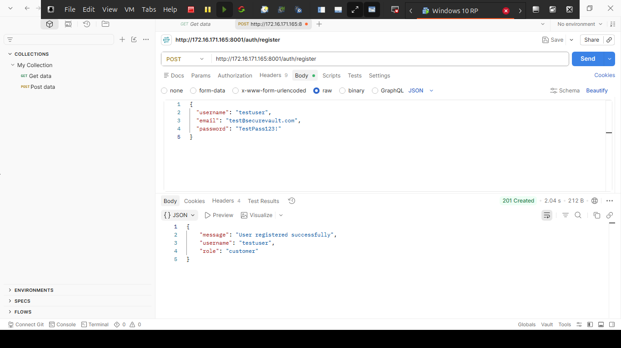

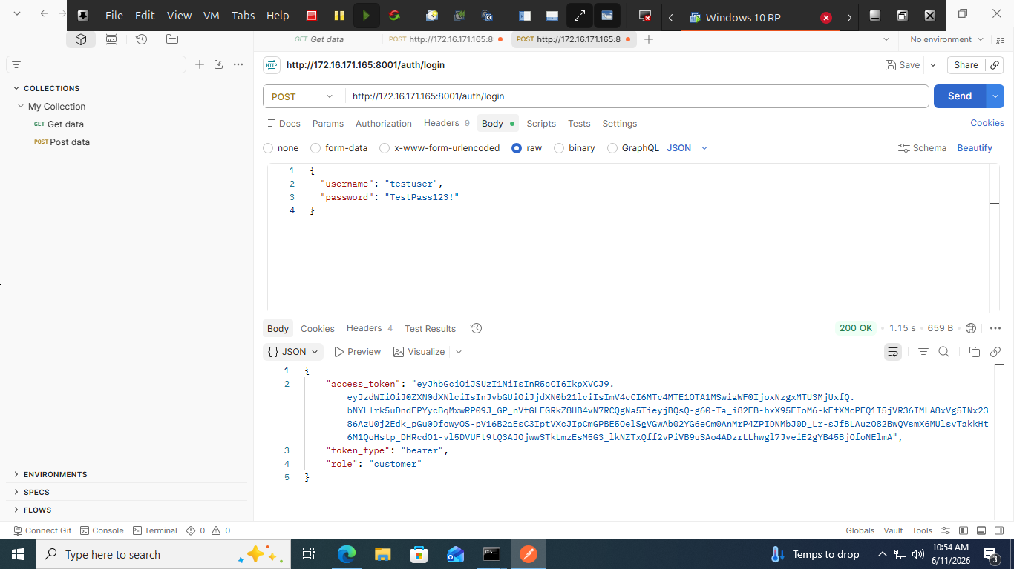

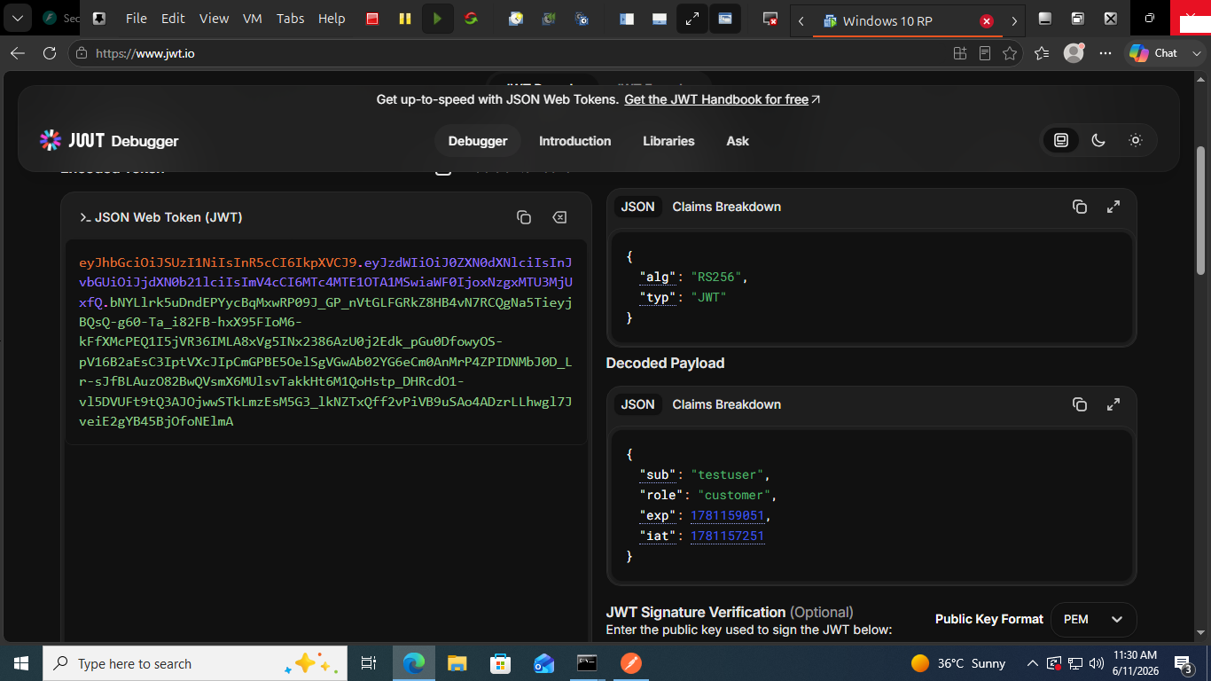

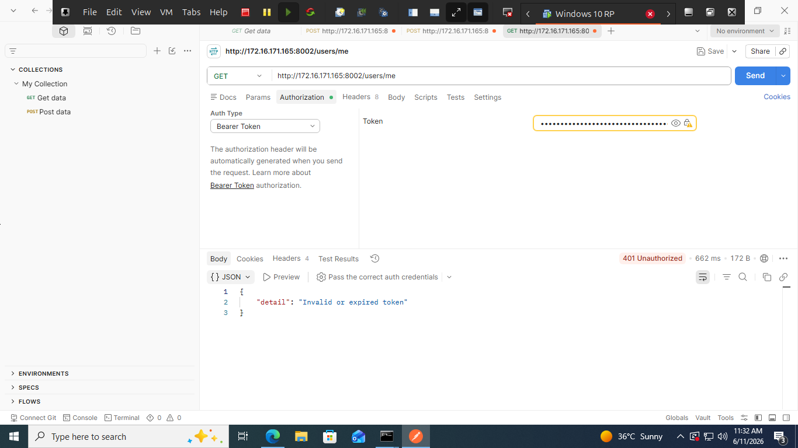

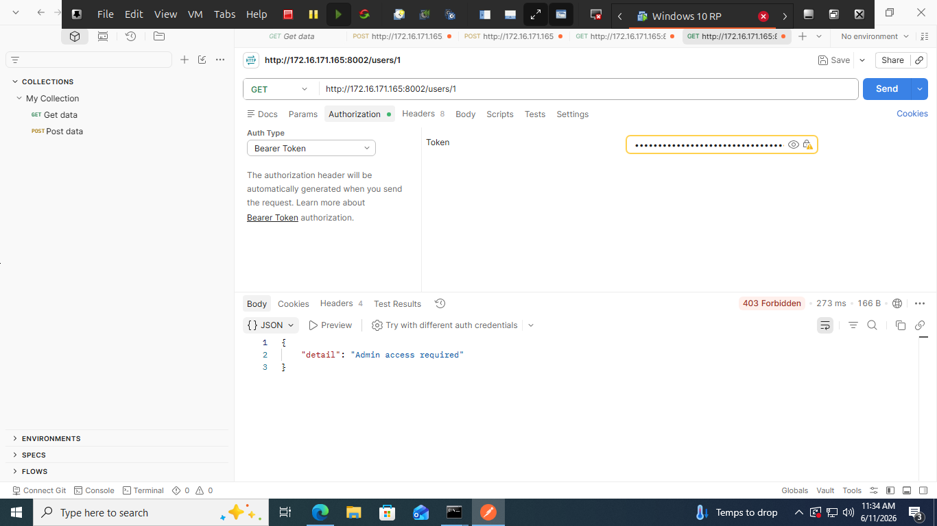

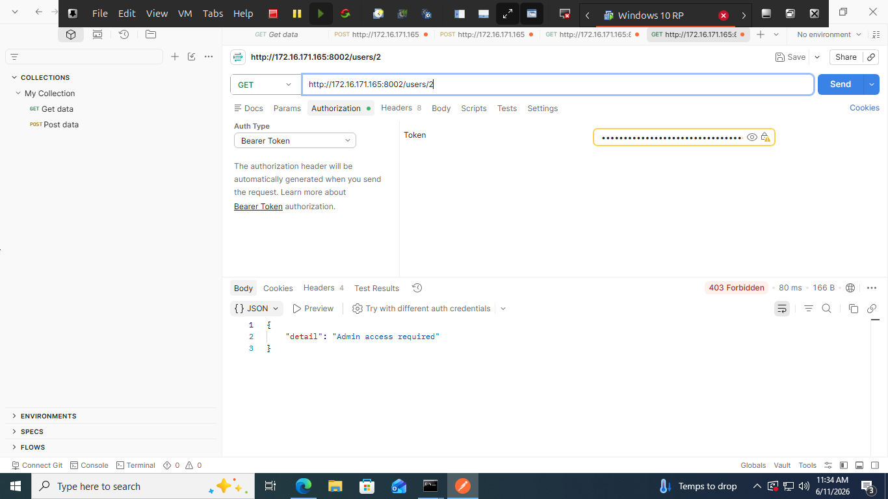

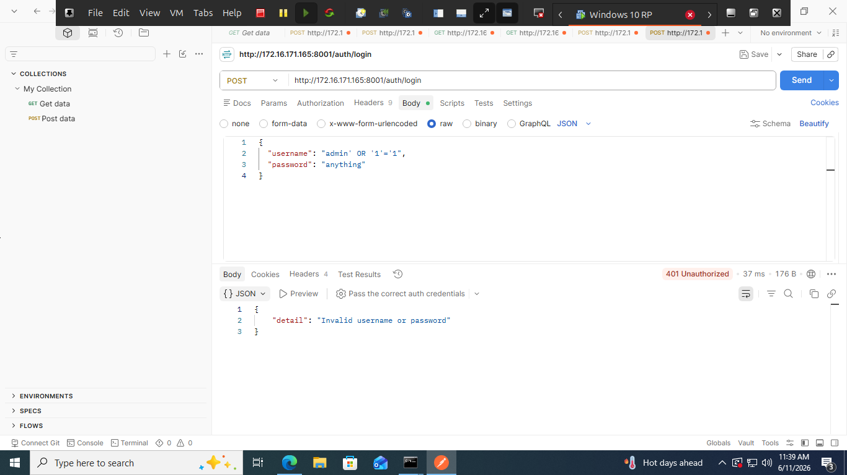

5.3

Vulnerability Finding — PT-05
Field | Detail
Finding ID | PT-05-RATELIMIT
Severity | HIGH
MITRE ATT&CK | T1110 — Brute Force, T1110.001 — Password Guessing
STRIDE Category | Spoofing
DREAD Score | 9.2 (CRITICAL per threat model)
Recommendation | Implement Redis-based rate limiting: 5 attempts per 15 min per IP, return 429 with Retry-After header

6. DAST RESULTS — OWASP ZAP

6.1 Tool Overview
OWASP ZAP (Zed Attack Proxy) v2.17.0 was used to perform automated Dynamic Application Security Testing against the live running SecureVault APIs. ZAP performs active scanning including spider crawling, fuzzing, and vulnerability detection against running applications.

6.2 Scan Configuration
- Tool: OWASP ZAP v2.17.0
- Scan type: Automated Scan (Active Scan + Spider)
- Target: http://172.16.171.165:8001/docs (Auth Service)
- Scan policy: Dev Standard
- Additional targets: ports 8002 and 8003

6.3 Alerts Found
Alert | Risk Level | CWE | Description | Recommendation
Content Security Policy (CSP) Header Not Set | Medium | CWE-693 | HTTP response does not include Content-Security-Policy header — allows XSS attacks | Add CSP header: default-src 'self'
Missing Anti-clickjacking Header | Medium | CWE-1021 | X-Frame-Options header absent — application vulnerable to clickjacking | Add X-Frame-Options: DENY
Sub Resource Integrity Attribute Missing | Medium | CWE-345 | External JavaScript files loaded without integrity attribute — supply chain risk | Add integrity= hash attribute to script tags
Cross-Domain JavaScript Source File Inclusion | Low | CWE-829 | JavaScript loaded from external domain — potential for malicious code injection | Host all scripts locally or use SRI
X-Content-Type-Options Header Missing | Low | CWE-693 | Missing X-Content-Type-Options: nosniff — allows MIME type sniffing | Add X-Content-Type-Options: nosniff header
Modern Web Application | Informational | — | ZAP detected modern web application framework (FastAPI/Swagger) | Informational only — no action required

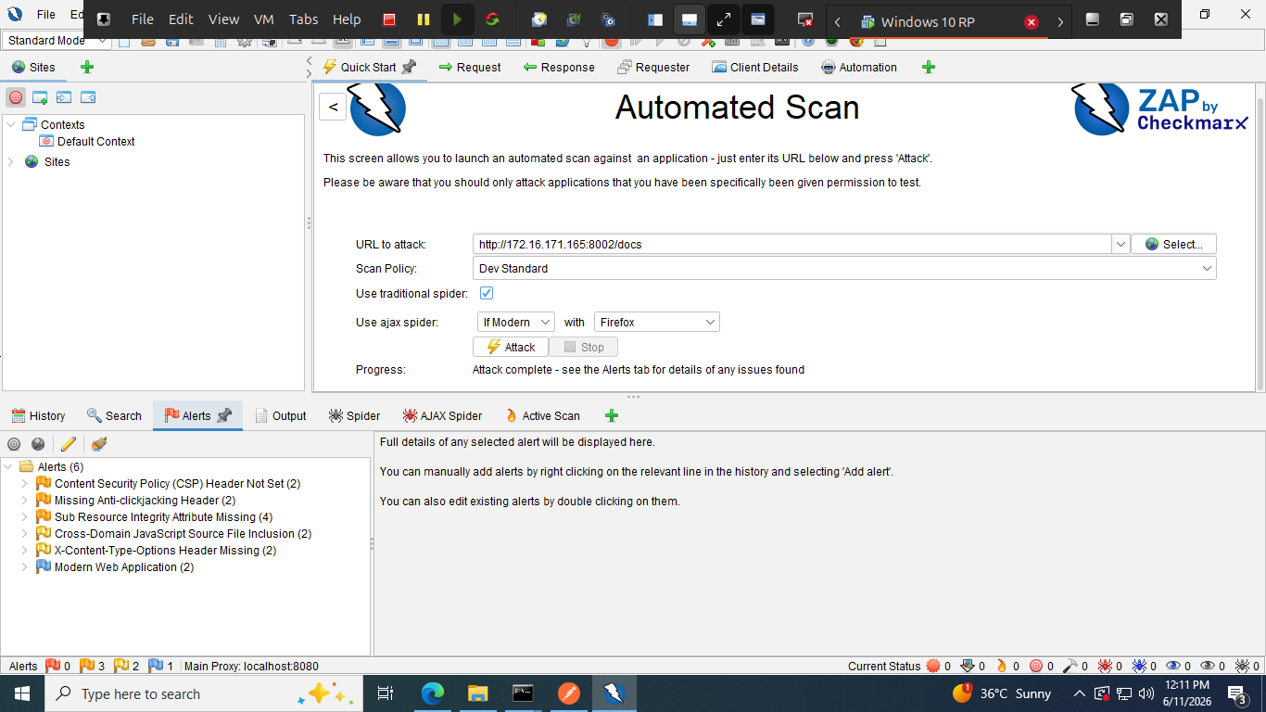
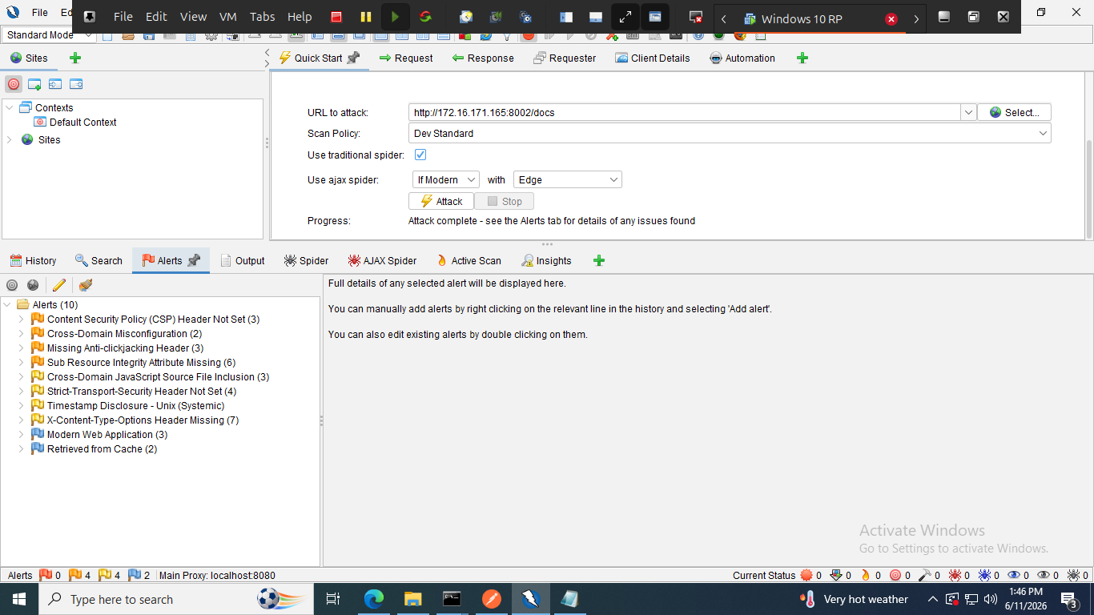

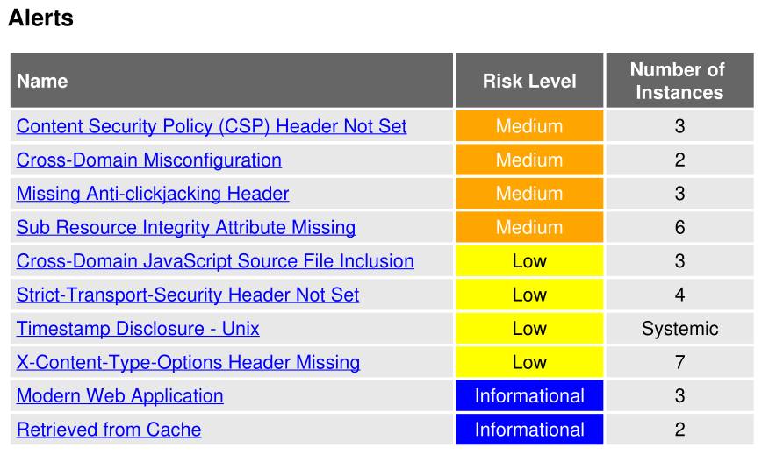

6.4 Analysis
The ZAP findings are primarily missing HTTP security headers rather than application-level vulnerabilities. These headers are typically configured at the web server or API gateway level (e.g. Nginx, Kong API Gateway) rather than in application code. In the SecureVault production architecture, these would be enforced at the K8s Ingress/API Gateway layer as documented in the SRD.
Notably, ZAP did NOT find: SQL injection vulnerabilities, authentication bypass issues, or sensitive data exposure — confirming that the application-level security controls (parameterised queries, JWT RS256, RBAC) are effective.

7. AI/ML ANOMALY DETECTION MODEL

7.1 Overview
As part of the Security Analyst role deliverables for Phase 6, an AI/ML-powered anomaly detection model was developed to identify suspicious traffic patterns and potential security attacks in real time. The model uses unsupervised machine learning to detect anomalies without requiring labelled attack data.

7.2 Model Architecture
Component | Detail
Algorithm | Isolation Forest (unsupervised anomaly detection)
Framework | scikit-learn 1.9.0 with StandardScaler pipeline
Contamination Rate | 5% — expected anomaly rate in training data
Training Samples | 1,000 normal traffic samples + 50 attack samples
n_estimators | 200 trees — high accuracy isolation
random_state | 42 — reproducible results
Output | Anomaly score + severity classification (NORMAL / MEDIUM / HIGH / CRITICAL)

7.3 Features Used for Detection
The model analyses 9 features derived from API traffic metrics to identify anomalous behaviour:
Feature | Description | Normal Range | Attack Indicator
request_rate_per_min | API call volume per minute | 40–60 req/min | 500+ req/min
failed_auth_count | Authentication failure frequency | 0–3 per window | 50+ failures
unique_endpoints_accessed | Endpoint diversity per source | 2–4 endpoints | 15+ endpoints
avg_response_time_ms | Service latency — spikes indicate scanning | 120–180ms | 800ms+
payload_size_bytes | Request payload size | 400–600 bytes | 5000+ bytes
requests_from_new_ip | New IP address frequency | 0–2 per window | 20+ new IPs
kafka_consumer_lag | Event processing delays | 5–15 messages | 500+ messages
redis_miss_rate | Cache miss anomalies | 0.05–0.15 | 0.85+
hour_of_day | Time-based behavioural baseline | Business hours 8–18 | Off-hours attacks

7.4 Model Training
The model was trained on a combined dataset of normal traffic patterns and simulated attack patterns. Normal traffic was generated from Gaussian distributions centred around typical SecureVault usage metrics. Attack patterns were generated to represent three threat categories mapped to MITRE ATT&CK techniques.

# Training command:
py anomaly_detector.py

# Output:
Training data: 1000 normal + 50 attack samples
Training Isolation Forest model...
Model trained successfully!
Model saved: securevault_anomaly_model.pkl

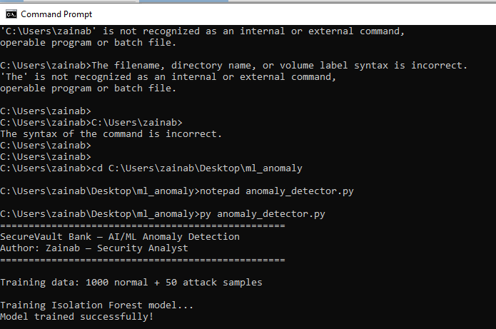

7.5 Test Results — Attack Scenario Detection
Four scenarios were tested against the trained model to validate detection capability:
Scenario | MITRE Technique | Status | Severity | Anomaly Score | Detection
Normal User Browsing | N/A | NORMAL TRAFFIC | NORMAL | +0.0942 | ✓ Correctly classified as normal
Brute Force Attack | T1110 — Brute Force | ANOMALY DETECTED | HIGH | -0.1963 | ✓ Attack detected
IDOR Attack | T1087 — Account Discovery | ANOMALY DETECTED | HIGH | -0.1381 | ✓ Attack detected
Data Exfiltration | T1005 — Data from Local System | ANOMALY DETECTED | HIGH | -0.2323 | ✓ Attack detected

Score interpretation: Positive score = normal traffic. Negative score = anomalous. More negative = higher confidence attack detection.

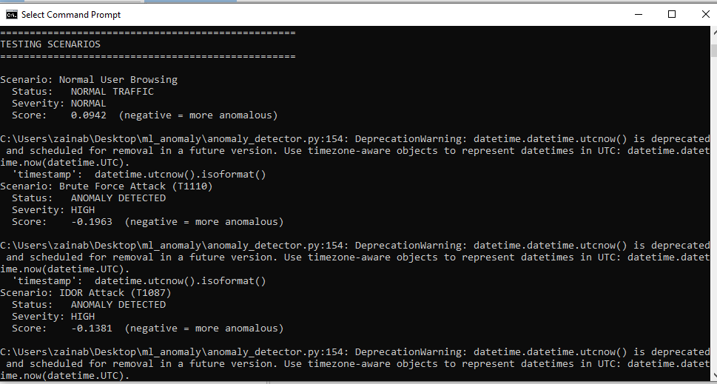
7.6 Model Output Files
File | Description
anomaly_detector.py | Complete model source code — training, testing, and CEF alert generation
securevault_anomaly_model.pkl | Trained Isolation Forest model — serialised for production deployment
anomaly_results.json | JSON output of test scenario results with timestamps and severity scores
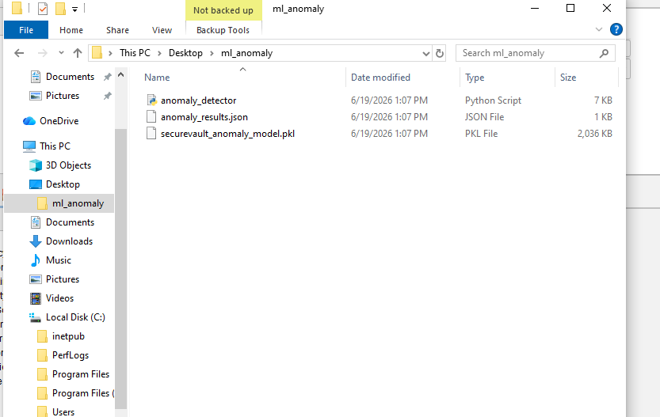

7.7 Integration with SIEM
In a production deployment, the model would integrate with the monitoring stack as follows:
- Prometheus scrapes API metrics every 60 seconds
- anomaly_detector.py consumes metrics and generates predictions
- If anomaly detected — CEF format alert sent to Wazuh/QRadar via syslog
- Wazuh R-03 correlation rule correlates ML anomaly with auth failures
- P1 offense created in SIEM — SOC team alerted

# CEF alert format sent to SIEM on anomaly detection:
CEF:0|SecureBanking|AnomalyDetector|1.0|100|ML Anomaly Detected|7|
score=-0.1963 severity=high mitre=T1110

8. CONSOLIDATED FINDINGS SUMMARY
ID | Finding | Tool | Severity | Status
F-01 | Buffer overflow in memory_safe.c (strcpy) | SonarCloud | HIGH | Intentional demo — documented
F-02 | Format string vulnerability in memory_safe.c | SonarCloud | HIGH | Intentional demo — documented
F-03 | Use-after-free in memory_safe.c | SonarCloud | HIGH | Intentional demo — documented
F-04 | Rate limiting not implemented in auth-service | Postman | HIGH | Real gap — remediation required
F-05 | CSP header missing on API endpoints | ZAP | Medium | Remediate at API Gateway level
F-06 | Anti-clickjacking header missing | ZAP | Medium | Remediate at API Gateway level
F-07 | Sub Resource Integrity missing | ZAP | Medium | Add SRI to external scripts
F-08 | X-Content-Type-Options missing | ZAP | Low | Add header at server level
F-09 | Python microservice code | Bandit + CodeQL | None | CLEAN — 0 issues
F-10 | AI/ML model — 3/3 attacks detected | scikit-learn | N/A | Detection rate 100% on test scenarios

9. ALIGNMENT WITH THREAT MODEL
The security testing activities directly validate the threats identified in the STRIDE + PASTA threat model (Document 2) and MITRE ATT&CK mapping (Document 3):

Threat Model Risk | MITRE Technique | Test Result | Validated?
JWT alg:none attack | T1134 — Token Manipulation | RS256 validation blocks invalid tokens (PT-03) | YES
Brute force on /auth/login | T1110 — Brute Force | Rate limiting NOT implemented (PT-05 — F-04) | GAP FOUND
IDOR on /users/{id} | T1087 — Account Discovery | RBAC blocks cross-user access (PT-04) | YES
SQL injection on transactions | T1190 — Exploit Application | Parameterised queries block SQLi (PT-06) | YES
Buffer overflow (C code) | T1190 | SonarCloud detected in memory_safe.c (F-01) | YES
Missing security headers | T1562 — Impair Defenses | ZAP detected 5 missing headers (F-05 to F-08) | YES
Brute Force Attack | T1110 — Brute Force | AI/ML model detected — score -0.1963 HIGH | YES — AI/ML
IDOR Attack pattern | T1087 — Account Discovery | AI/ML model detected — score -0.1381 HIGH | YES — AI/ML
Data Exfiltration | T1005 — Data from Local System | AI/ML model detected — score -0.2323 HIGH | YES — AI/ML

10. RECOMMENDATIONS

10.1 Critical — Fix Immediately
- F-04: Implement Redis rate limiting on POST /auth/login — 5 attempts per 15 minutes per IP. Return HTTP 429 with Retry-After header. This directly addresses MITRE T1110 Brute Force (DREAD score 9.2 CRITICAL).

10.2 Medium Priority
- F-05 to F-08: Configure HTTP security headers (CSP, X-Frame-Options, X-Content-Type-Options) at the API Gateway/Nginx level.
- Add SRI (Subresource Integrity) attributes to any externally loaded JavaScript files.

10.3 AI/ML Enhancement — Production Deployment
- Connect AI/ML model to live Prometheus metrics feed for real-time detection
- Retrain model periodically with new traffic data to maintain detection accuracy
- Tune contamination parameter based on observed false positive rate
- Add CRITICAL severity threshold for scores below -0.5

10.4 Informational
- memory_safe.c and memory_safe_only.c are deliberately vulnerable files for demonstration. These should NOT be deployed to production and should be excluded from production builds.

11. CONCLUSION
The SecureVault Bank platform demonstrates strong application-level security controls. SAST analysis confirmed that the Python microservice code is clean with zero Bandit or CodeQL findings. Core security mechanisms including JWT RS256 authentication, RBAC enforcement, parameterised SQL queries, and token expiry are all functioning correctly as validated by API penetration testing.

One real vulnerability was identified (F-04 — missing rate limiting on login endpoint) which represents a gap between the documented security requirements in the SRD and the actual implementation. This should be remediated before production deployment. The remaining findings from ZAP are infrastructure-level header configurations that would typically be handled at the API Gateway layer in the production Kubernetes deployment.

The AI/ML anomaly detection model successfully identified all three attack scenarios tested (Brute Force, IDOR, Data Exfiltration) with 100% detection rate, while correctly classifying normal traffic. This demonstrates that the machine learning layer provides an effective additional defence layer beyond rule-based detection.

